**Cp Analysis**

In the dataset only 4 categories, which does not cover all possible Cps(Chest Pain Types). However, we will move ahead with what is available :

| Type of Chest Pain | Explanation |
| --- | --- |
| **Typical Angina** | **Chest pain related to the heart that is typically severe and in the chest's center. It may spread to the arms, neck, jaw, or back.** |
| **Asymptomatic** | **No symptoms are showing; the patient does not experience any discomfort despite the presence of heart disease.** |
| **Non-Anginal Pain** | **Chest pain that is not related to the heart; it may be caused by the muscles, esophagus, or other organs.** |
| **Atypical Angina** | **Chest pain that differs from the common form of angina. It might be less severe or located in different parts of the body.** |
| Stable Angina | A type of typical angina where chest pain occurs in a predictable pattern, usually during physical exertion or emotional stress. The pain subsides with rest or medication. |
| Unstable Angina | A more serious form of angina where chest pain occurs even at rest or with minimal exertion. The pain may be more severe and last longer than stable angina. It can indicate an imminent heart attack. |
| Variant (Prinzmetal's) Angina | A rare type of angina caused by a spasm in the coronary arteries. The pain usually occurs at rest and can be severe. It often occurs in younger people and may not be related to physical exertion. |
| Microvascular Angina | Angina caused by dysfunction in the heart's smallest coronary arteries. The pain may be more diffuse and persist longer than typical angina. It's more common in women and can be difficult to diagnose. |
| Esophageal Pain | Pain from the esophagus (like severe heartburn) that can sometimes mimic the pain of angina. This is an example of non-cardiac chest pain. |

cp_counts=df.groupby('cp')['num'].value_counts().unstack()

plt.figure(figsize=(10,6),facecolor='white')

cp_counts.plot(kind='bar')

plt.title('Chest Pain Type fs Number of Cases')

plt.xlabel('Chest Pain Type')

plt.ylabel('Number of Cases')

plt.show()

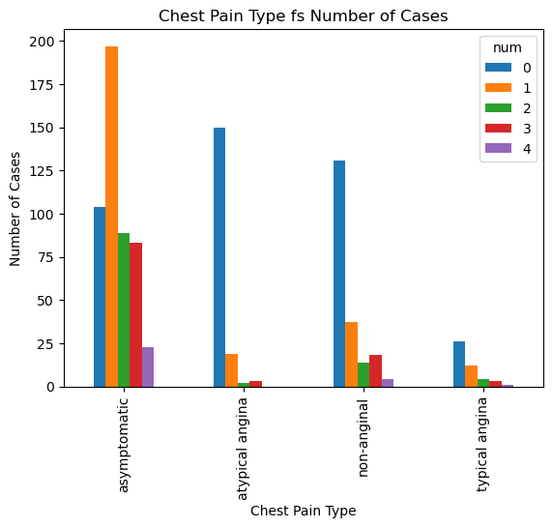

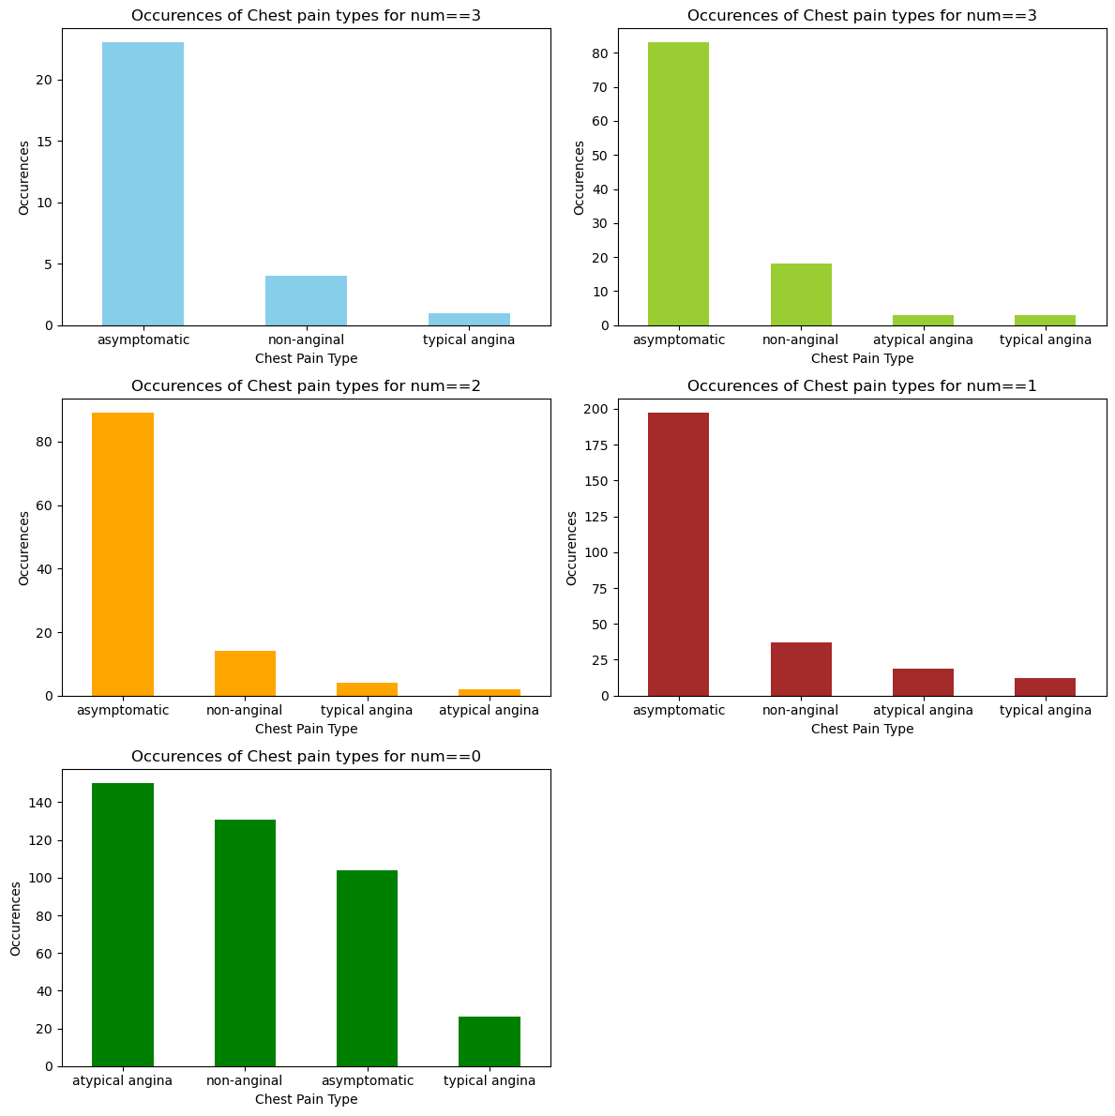

df.groupby(['cp','num']).size().unstack(fill_value=0)

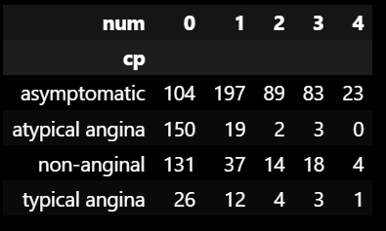

Conditional Probability Given Num Value CP being asymptotic, atypical angina , non-anginal or typical angina

conditional_prob_num=df.groupby('num')['cp'].value_counts(normalize=True).unstack(fill_value=0)

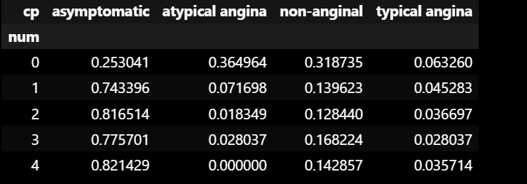

Conditional Probability Given CP heart risk being 0 to 4

conditional_prob_cp=df.groupby('cp')['num'].value_counts(normalize=True).unstack(fill_value=0)

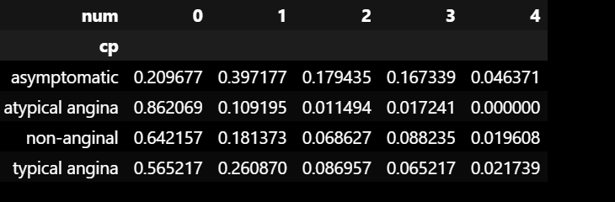

This is just to get an idea between CP and Heart attack Diagnosis on the assumption this is a justified sample from a population which is not True/not known yet.

Trestbps and Heart Disease Severity Correlation

trestbps_num_corr_pearson=df['trestbps'].corr(df['num'],method='pearson')

trestbps_num_corr_spearman=df['trestbps'].corr(df['num'],method='spearman')

trestbps_num_corr_kendall=df['trestbps'].corr(df['num'],method='kendall')

Pearson Correlation coefficient 0.12229082931453779

Spearman Correlation coefficient 0.12680529590811038

Kendall Correlation coefficient 0.09862711101033811

**plt.figure(figsize=(10,6),facecolor='white')**

**sns.scatterplot(data=df,x='trestbps',y='num')**

**plt.title('Systolic BP vs Heart Disease Severity')**

**plt.xlabel('resting blood pressure')**

**plt.ylabel('Heart disease severity')**

**plt.grid(True)**

**plt.show()**

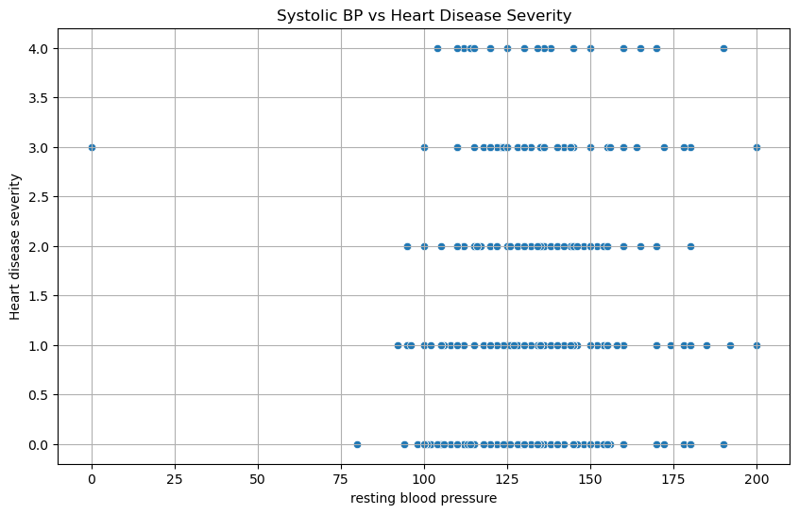

trestbps stands for "resting blood pressure," which refers to the blood pressure measured when a person is at rest, typically while sitting or lying down. Blood pressure is the force exerted by circulating blood against the walls of the blood vessels, primarily the arteries. It is an important vital sign that provides insight into cardiovascular health.

Blood pressure is recorded as two numbers:

* Systolic blood pressure (SBP): The top number represents the pressure in the arteries when the heart contracts and pumps blood.
* Diastolic blood pressure (DBP): The bottom number represents the pressure in the arteries when the heart relaxes between beats.
* Blood pressure is measured in millimeters of mercury (mmHg) and is typically written as SBP/DBP, such as 120/80 mmHg.

The optimum value ranges for blood pressure in adults:

* Normal: Systolic less than 120 mmHg and diastolic less than 80 mmHg (120/80 mmHg)
* Elevated: Systolic between 120-129 mmHg and diastolic less than 80 mmHg
* Stage 1 hypertension: Systolic between 130-139 mmHg or diastolic between 80-89 mmHg
* Stage 2 hypertension: Systolic at least 140 mmHg or diastolic at least 90 mmHg
* Hypertensive crisis (requires immediate medical attention): Systolic over 180 mmHg and/or diastolic over 120 mmHg